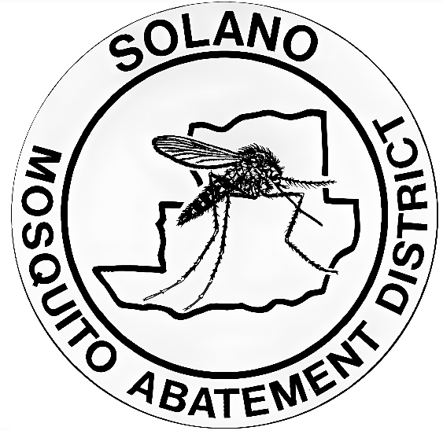

Press Release
August 29, 2024

West Nile Virus Detection
The Solano County Mosquito Abatement District (SCMAD) has detected the presence of West Nile virus in two locations in the city of Dixon, CA on August 28, 2024. The map below indicates the area where the infected mosquitoes have been detected. Residents are advised to take preventive measures to reduce the risk of mosquito bites and protect public health by inspecting their properties for standing water. SCMAD urges residents to be proactive against mosquitoes by wearing EPA-registered insect repellent containing active ingredients such as DEET, picaridin, oil of lemon eucalyptus, or IR3535 if they plan to be in the area. Technicians are carrying out control as necessary in the surrounding areas to reduce the number of mosquitoes and interrupt further transmission of the virus. The District will continue to monitor the area.
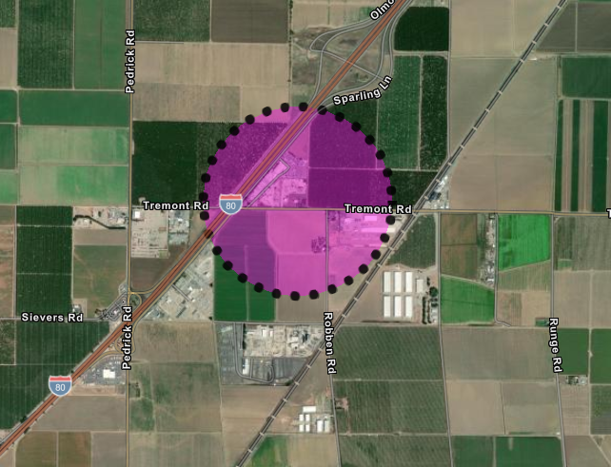
The first detection is located off Tremont Road and Interstate 80

Use this link to access interactive map
https://solanocountymosq.maps.arcgis.com/apps/instant/notification/index.html?appid=9004e84ec9ee4ed2b2d3cfd334ebed2d
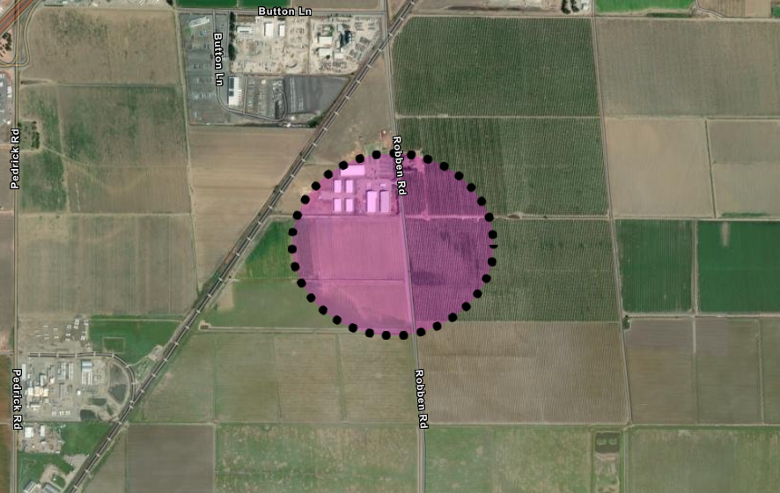
The second detection is located off Robben Road in Dixon

Use this link to access interactive map
https://solanocountymosq.maps.arcgis.com/apps/instant/notification/index.html?appid=eb47dfe2c1964c6882a2c27c9ab95e1f
West Nile Information
Transmission: West Nile virus (WNV) spreads when a female mosquito bites an infected bird and then bites a person.
Symptoms: Most people show no symptoms. Some may have fever, headaches, and body aches. Severe cases can lead to hospitalization and, rarely, death. If you have symptoms, contact your healthcare provider.
High-Risk Groups: Elderly people and those with chronic conditions (diabetes, high blood pressure, cancer, kidney disease) are at higher risk for serious complications.

Preventing West Nile Virus
To reduce mosquito breeding on your property:
Check for standing water. Drain standing water. Empty items like flowerpots, planter dish, pet dishes, buckets, and old tires. Clean regularly, wash bird baths and pet bowls weekly. Repair leaky faucets and broken sprinkler heads. Avoid over-watering. Ensure window and door screens are intact, have no holes, and fit well. Keep swimming pools at proper water levels for circulation and filtration. Request free mosquito fish for neglected pools, ornamental ponds, water troughs, and other artificial bodies of water.

About The District
SCMAD plays a crucial role in controlling mosquito populations across both incorporated and unincorporated areas of Solano County, which spans over 900 square miles. Established in 1930, SCMAD has been committed to protecting public health and improving the quality of life for residents by reducing the risk of mosquito-borne diseases. Over the years, the district has implemented a variety of strategies, including surveillance, public education, and environmentally responsible treatments, to effectively manage mosquito populations. The dedicated efforts of SCMAD ensure that the community remains safer from the threats posed by mosquitoes, West Nile virus, and other vector-borne illnesses.

Contact us at
707-437-1116
solmad@solanomosquito.com
Website www.solanomosquito.com
Sign up for email notifications at
www.solanomosquito.com/stay-in-touch
Follow us on Instagram

