|  |  |
| --- | --- |
|  |  |

**Press Release**

September 25, 2024

**West Nile Virus Detection**

The Solano County Mosquito Abatement District (SCMAD) has detected the presence of West Nile virus in two locations in the city of Dixon on September 24, 2024. The maps below show the area where the infected mosquitoes were found. West Nile virus has been previously detected at both sites. Residents are advised to take preventive measures to reduce the risk of mosquito bites and protect public health by inspecting their properties for standing water. SCMAD urges residents to be proactive against mosquitoes by wearing EPA-registered insect repellent if they plan to be in the area. Technicians are working in the surrounding areas to reduce mosquito numbers and stop the virus from spreading. The District will keep monitoring the area.

Detection site of first finding.

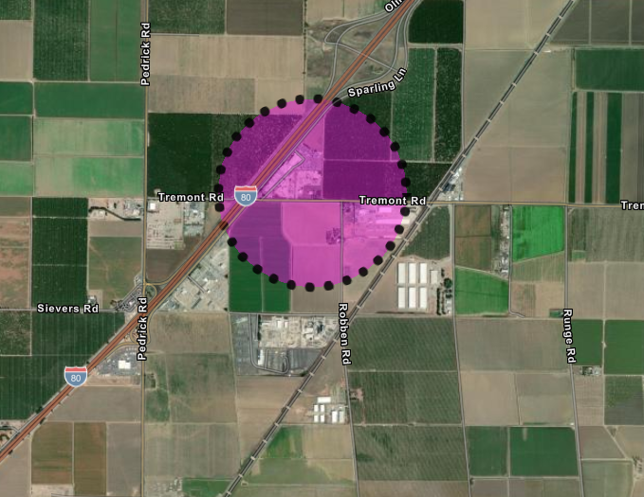

Use this link to access the interactive map of the first finding.

<https://solanocountymosq.maps.arcgis.com/apps/instant/notification/index.html?appid=cb125ddcc6584078b7d97bda6fc06872>

Detection site of second finding.

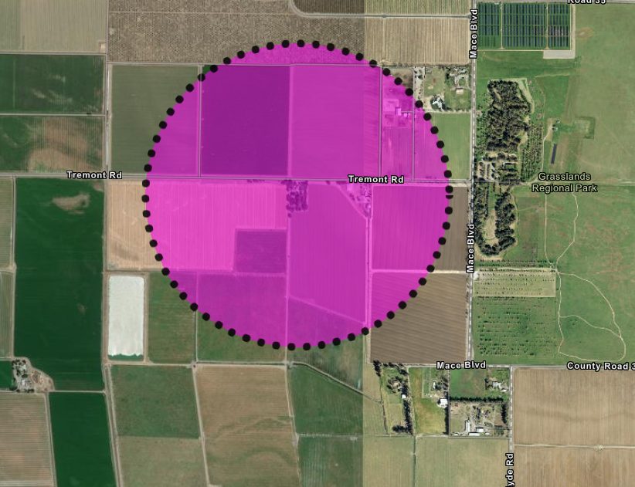

Use this link to access the interactive map of the second finding.

<https://solanocountymosq.maps.arcgis.com/apps/instant/notification/index.html?appid=e7260ecdd31a48308def6917dbb16418>

**West Nile Information**

Transmission: West Nile virus (WNV) spreads when a female mosquito bites an infected bird and then bites a person.

Symptoms: Most people show no symptoms. Some may have fever, headaches, and body aches. Severe cases can lead to hospitalization and, rarely, death. If you have symptoms, contact your healthcare provider.

High-Risk Groups: Elderly people and those with chronic conditions (diabetes, high blood pressure, cancer, kidney disease) are at higher risk for serious complications.

**Preventing West Nile Virus**

Help prevent West Nile virus by eliminating mosquito breeding on your property:

Check for standing water. Drain standing water. Empty items like flowerpots, planter dish, pet dishes, buckets, and old tires. Clean regularly, wash bird baths and pet bowls weekly. Repair leaky faucets and broken sprinkler heads. Avoid over-watering. Ensure window and door screens are intact, have no holes, and fit well. Keep swimming pools at proper water levels for circulation and filtration. Request free mosquito fish for neglected pools, ornamental ponds, water troughs, and other artificial bodies of water.

**About The District**

SCMAD plays a crucial role in controlling mosquito populations across both incorporated and unincorporated areas of Solano County, which spans over 900 square miles. Established in 1930, SCMAD has been committed to protecting public health and improving the quality of life for residents by reducing the risk of mosquito-borne diseases. Over the years, the district has implemented a variety of strategies, including surveillance, public education, and environmentally responsible treatments, to effectively manage mosquito populations. The dedicated efforts of SCMAD ensure that the community remains safer from the threats posed by mosquitoes, West Nile virus, and other vector-borne illnesses.

Contact us at

707-437-1116

[solmad@solanomosquito.com](mailto:solmad@solanomosquito.com)

Website [www.solanomosquito.com](http://www.solanomosquito.com)

Sign up for email notifications at

[www.solanomosquito.com/stay-in-touch](http://www.solanomosquito.com/stay-in-touch)

Follow us on Instagram