|  |  |
| --- | --- |
|  |  |

Press Release

September 20, 2024

**Detection of Invasive Mosquito**

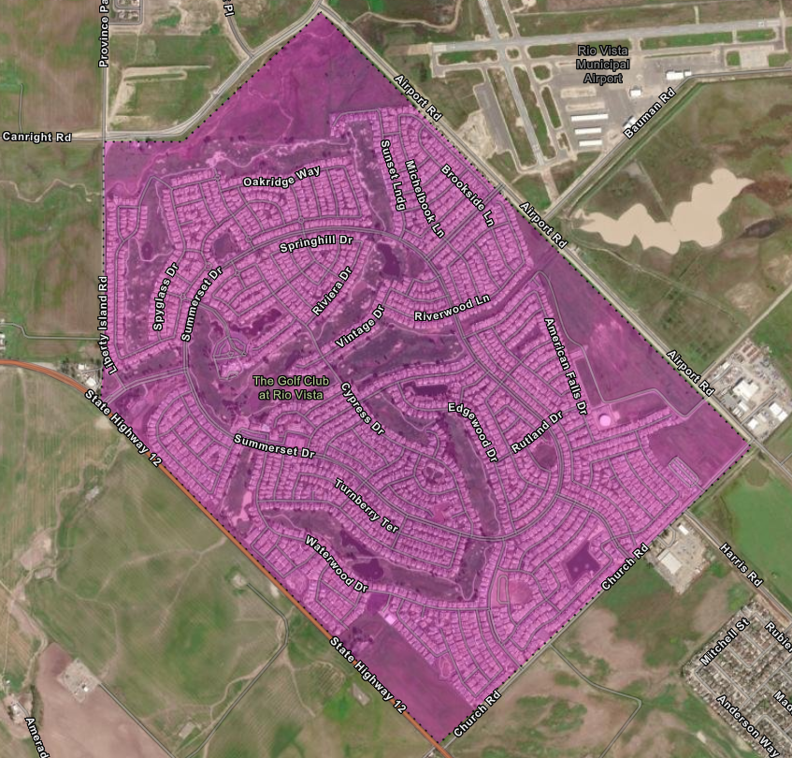The Solano County Mosquito Abatement District (SCMAD) has detected the presence of the invasive *Aedes aegypti* mosquito in the city of **Rio Vista** on September 18, 2024. *Aedes aegypti* is a crucial vector in public health because it can transmit several dangerous viruses, such as dengue, Zika, chikungunya, and yellow fever. Being proactive is key to deterring mosquito breeding. Residents are advised to take preventive measures to reduce the spread of this mosquito by inspecting their properties for standing water and eliminating it whenever possible. This includes emptying items like flowerpots, planter dishes, pet dishes, buckets, and old tires. Additionally, the District urges residents to report any observance of day-biting mosquitoes to 707-437-1116 or email at solmad@solanomosquito.com. The District will continue to monitor the area closely to manage and mitigate the spread of *Aedes aegypti*.

Use the link below to access the interactive map for better viewing.

<https://solanocountymosq.maps.arcgis.com/apps/instant/notification/index.html?appid=341aa667e57a4ec8acbe10504e0fda13>

**Information About *Aedes aegypti***

*Aedes aegypti* is a highly significant vector in public health due to its role in transmitting several dangerous viruses, including dengue, Zika, chikungunya, and yellow fever. These diseases can lead to severe health complications, neurological disorders, birth defects, and in some cases, death.

Controlling *Aedes aegypti* is critical because this mosquito species is highly adaptive and thrives in urban environments. They are aggressive daytime biters, often residing close to human dwellings, making it easier for them to spread viruses quickly. The ability of *Aedes aegypti* to breed in small amounts of standing water, such as in discarded containers, makes them difficult to control once populations are established.

Reducing the population of *Aedes aegypti* earlyhelps to prevent the mosquito from establishing and minimizes new risks of mosquito-borne diseases spreading within communities.

**Prevent Mosquito Breeding On Your Property**

To reduce mosquito breeding on your property, regularly inspect for any standing water and drain it whenever possible. This includes emptying items like flowerpots, planter dishes, pet dishes, buckets, and old tires. Repair any leaky faucets and broken sprinkler heads and avoid over-watering your plants. Ensure that window and door screens are intact, free of holes, and fit well. Keep swimming pools at proper water levels to maintain circulation and filtration. Additionally, you can request free mosquito fish for neglected pools, ornamental ponds, water troughs, and other artificial bodies of water.

**About The District**

SCMAD plays a crucial role in controlling mosquito populations across both incorporated and unincorporated areas of Solano County, which spans over 900 square miles. Established in 1930, SCMAD has been committed to protecting public health and improving the quality of life for residents by reducing the risk of mosquito-borne diseases. Over the years, the district has implemented a variety of strategies, including surveillance, public education, and environmentally responsible treatments, to effectively manage mosquito populations. The dedicated efforts of SCMAD ensure that the community remains safer from the threats posed by mosquitoes, West Nile virus and other vector-borne illnesses.

Contact us at

Office phone number 707-437-1116

[solmad@solanomosquito.com](mailto:solmad@solanomosquito.com)

Website [www.solanomosquito.com](http://www.solanomosquito.com)

Sign up for email notifications at

[www.solanomosquito.com/stay-in-touch](http://www.solanomosquito.com/stay-in-touch)

Stay In Touch

Follow us on Instagram